**Phase I: Choose Application and E/R Design**

**Application Description**

Book Publisher Management System is an application, designed to manage relationships between books, their authors, publishers, and genres. This includes:

• **Authors**: People who write books.

• **Books**: Written by authors, published by publishers, and categorized in genres.

• **Publishers**: Organization that handles the publishing of books

• **Genres**: Classified names given to books for easier management.

**Entities and Attributes**

1. **Author:**

**Attributes:**

AuthorID (Primary Key)

Name

Bio

2. **Publisher:**

**Attributes:**

PublisherID (Primary Key)

Name

Address

3. **Genre:**

**Attributes:**

GenreID (Primary Key)

Name

4. **Book:**

**Attributes:**

BookID (Primary Key)

Title

AuthorID (Foreign Key)

PublisherID (Foreign Key)

GenreID (Foreign Key)

**Relationships**

1. Author Book: One-to-Many

Each author can write many books, but a book is written by only one author.

2. Publisher Book: One-to-Many

Each publisher can publish many books, but a book is published by only one publisher.

3. Genre Book: One-to-Many

Each genre can be assigned to many books, but a book belongs to one genre.

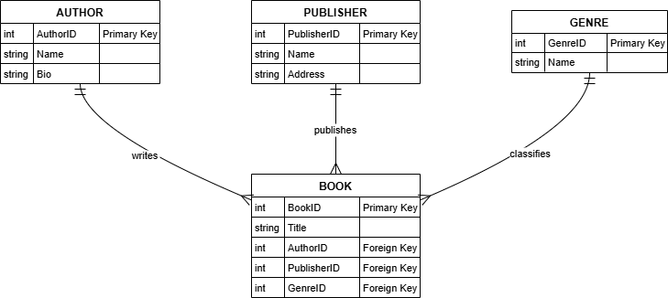

**Phase II: E/R Design to Relational Database.**

**Relational Schema.**

**1. Author.**

• AuthorID (PK).

• Name.

• Bio.

**2. Publisher.**

• PublisherID (PK).

• Name.

• Address.

**3. Genre.**

• GenreID (PK).

• Name.

**4. Book.**

• BookID (PK).

• Title.

• AuthorID (FK).

• PublisherID (FK).

• GenreID (FK).

**Keys and Functional Dependencies:**

**1. Author:**

o Primary Key: AuthorID.

o Functional Dependency: AuthorID ́} {Name, Bio}.

**2. Publisher:**

o Primary Key: PublisherID.

o Functional Dependency: PublisherID ́} {Name, Address}.

**3. Genre:**

o Primary Key: GenreID.

o Functional Dependency: GenreID ́}{Name}.

**4. Book**:

o Primary Key: BookID.

o Functional Dependencies:

BookID ́{Title, AuthorID, PublisherID, GenreID}.

AuthorID ́{Name, Bio}.

PublisherID ́{Name, Address}.

GenreID ́{Name}.

**Normalization.**

1. First Normal Form (1NF):

o All attributes contain atomic values.

o Example: GenreID in Book refers to one specific genre.

2. Second Normal Form (2NF):

o All non-key attributes are fully functionally dependent on the primary key.

o No partial dependencies (e.g., Title depends only on BookID).

3. Third Normal Form (3NF):

o No transitive dependencies.

o Example: Name of a genre is only dependent on GenreID.

The schema is fully normalized to 3NF.

**Phase III:**

**Database Schema**

-- Create the database

CREATE DATABASE book_publisher;

-- Use the created database

USE book_publisher;

-- Create the authors table

CREATE TABLE author (

id BIGINT AUTO_INCREMENT PRIMARY KEY,

name VARCHAR(255) NOT NULL,

bio TEXT

);

-- Create the publishers table

CREATE TABLE publisher (

id BIGINT AUTO_INCREMENT PRIMARY KEY,

name VARCHAR(255) NOT NULL,

address VARCHAR(255)

);

-- Create the genres table

CREATE TABLE genre (

id BIGINT AUTO_INCREMENT PRIMARY KEY,

name VARCHAR(255) NOT NULL

);

-- Create the books table

CREATE TABLE book (

id BIGINT AUTO_INCREMENT PRIMARY KEY,

title VARCHAR(255) NOT NULL,

author_id BIGINT NOT NULL,

publisher_id BIGINT NOT NULL,

genre_id BIGINT NOT NULL,

FOREIGN KEY (author_id) REFERENCES author(id),

FOREIGN KEY (publisher_id) REFERENCES publisher(id),

FOREIGN KEY (genre_id) REFERENCES genre(id)

);

**Sample Data**

INSERT INTO author (name, bio) VALUES

('Jane Austen', 'Author of Pride and Prejudice'),

('George Orwell', 'Author of 1984'),

('J.K. Rowling', 'Author of the Harry Potter series'),

('Mark Twain', 'Author of The Adventures of Tom Sawyer'),

('F. Scott Fitzgerald', 'Author of The Great Gatsby'),

('Charles Dickens', 'Author of A Tale of Two Cities'),

('Virginia Woolf', 'Author of Mrs. Dalloway'),

('Harper Lee', 'Author of To Kill a Mockingbird'),

('Leo Tolstoy', 'Author of War and Peace'),

('Ernest Hemingway', 'Author of The Old Man and the Sea');

INSERT INTO publisher (name, address) VALUES

('Penguin Random House', '1745 Broadway, New York, NY'),

('HarperCollins', '195 Broadway, New York, NY'),

('Bloomsbury', '50 Bedford Square, London, UK'),

('Macmillan', '120 Broadway, New York, NY'),

('Simon & Schuster', '1230 Avenue of the Americas, New York, NY'),

('Hachette', '1290 Avenue of the Americas, New York, NY'),

('Scholastic', '557 Broadway, New York, NY'),

('Oxford University Press', 'Great Clarendon Street, Oxford, UK'),

('Cambridge University Press', 'University Printing House, Cambridge, UK'),

('McGraw Hill', '1325 Avenue of the Americas, New York, NY');

INSERT INTO genre (name) VALUES

('Fiction'),

('Science Fiction'),

('Fantasy'),

('Historical'),

('Biography'),

('Mystery'),

('Romance'),

('Horror'),

('Adventure'),

('Classics');

INSERT INTO book (title, author_id, publisher_id, genre_id) VALUES

('Pride and Prejudice', 1, 1, 1),

('1984', 2, 2, 2),

('Harry Potter and the Philosopher\'s Stone', 3, 3, 3),

('The Adventures of Tom Sawyer', 4, 4, 9),

('The Great Gatsby', 5, 5, 1),

('A Tale of Two Cities', 6, 1, 4),

('Mrs. Dalloway', 7, 6, 1),

('To Kill a Mockingbird', 8, 7, 1),

('War and Peace', 9, 8, 4),

('The Old Man and the Sea', 10, 9, 1);

**Phase IV :**

